AIOC 2026
HANDOUTS
IC No: IC 9
Abstract Title: Infectious uveitis-practical challenges in diagnosis and management: a case based approach
Chief Instructor: Dr.Jyotirmay Biswas
Co-Instructors & Course outline:
Laboratory tests in infectious uveitis- when to order, what to order,what best we can get : Dr.Jyotirmay Biswas
Viral retinitis- real emergency in uveitis : Vinita Girish Rao
Many face of Toxoplasma uveitis: Dr.Amala Elizabeth George
Post fever retinitis -can we find the cause and bring back vision: Dr.Suchitra Pradeep
Syphilitic uveitis- reemergence of an age- old disease: Dr.Mudit Tyagi
TB or not TB - a perennial question: Dr.Sudha Ganesh
Panel discussion

Laboratory tests in infectious uveitis-when to ask, what to order and what best we can see
Prof. Dr. Jyotirmay Biswas MS. FMRF, FAMS, FIC Path., FAICO, FNAsc, FRCS (Ed), FACS,
Distinguished senior consultant of Uveitis & Ocular Pathology Department,
Emeritus Professor, National Academy of Medical Sciences, India
Sankara Nethralaya,
41, College Road, Nungambakkam
Chennai – 600 006, Tamil Nadu, India.
Phone: 91-44-28271616; Fax: - 91-44-2825 4180
Mobile No: 9841428151; E-mail: drjb@snmail.org
- Introduction
Laboratory investigations in uveitis should never be ordered indiscriminately. A detailed stepwise clinical approach is essential to narrow the differential diagnosis, avoid unnecessary tests and ensure appropriate management. The following steps outline the rational framework to be followed before ordering investigations in suspected infectious uveitis.

Take uveitis- oriented history
Complete eye exam-identify
anatomic location and extent
of primary uveitis
Get an overall systemic
evaluation

- Compare clinical characteristics with known uveitic entities
- Shortlist aetiological possibilities
- Order first relevant lab investigations
- Order extensive investigations- if refractory to your treatment.

- Why lab tests matter
- Differentiate infectious vs non-infectious uveitis
- Prevent inappropriate immunosuppression
- Detect systemic infections (e.g. syphilis, HIV)
- Address clinical overlap: Behcet’s may mimic ARN.¹

Guide targeted antimicrobial therapy
- Predict course and recurrence (e.g. Herpetic uveitis).2

- Diagnostic Approaches in Infectious Uveitis

Laboratory diagnosis can be broadly divided into:

A. Direct Evidence of  Infection | B. Indirect Evidence of  Infection
Demonstration of the organisms  in ocular fluids or tissues and culture- gold standard. | Detection of systemic immune  response or markers of infection elsewhere in the body.
PCR-detects the presence of  genetic materials of pathogens in ocular fluid-does not support koch’s postulates.3 | These tests are supportive and  require clinical correlation.

- Direct evidence of infection:
  - Laboratory Techniques for Direct Detection

Microscopy and Staining/culture
    - Ziehl–Neelsen /Auramine: Mycobacterium tuberculosis.
    - Dark-field microscopy: A) historically used for spirochetes.4
    - B) Leptospira-blood and urine samples.5
    - Fite-Faraco stain: Gold standard for leprosy.6
    - Culture.

Limitations: Cultures tend to be negative because of low organism load and slow growth as seen in ocular tuberculosis.7
Negative culture does not exclude infection: Uveitis may occur
due to immune-mediated hypersensitivity to infectious agents located elsewhere, where direct organism detection may not be possible.8

  - Ocular Samples

Aqueous Humor
    - Easily obtained by anterior chamber paracentesis
    - Can be done as an outpatient procedure
    - Lower diagnostic yield in posterior uveitis

Vitreous Humor
    - Higher diagnostic yield in posterior segment inflammation
    - Diagnostic and therapeutic vitrectomy in some cases.9
    - Undiluted vitreous (1–2 mL) preferred for PCR and culture.
    - Diagnostic yield for infectious uveitis ranges from ~28% to 77% .10-13

Tissue Biopsy
    - Iris or chorioretinal biopsy
    - Higher diagnostic accuracy (Iris biopsy in Bartonella uveitis.)14
    - Reserved for selected cases due to higher risk of structural damage
    - Particularly useful in masquerade syndromes.

- Indirect evidence:
  - Serological and Immunological tests

DISEASE | TESTS | COMMENTS
SYPHILIS | - Non-treponemal tests: VDRL, RPR (disease activity and response to treatment)- VDRL preferred over RPR in CSF of neurosyphilis.  - Treponemal tests: TPPA, FTA-ABS (remain positive lifelong).¹⁵ | -Must be tested in all cases of uveitis  - Diagnosis requires both test types  - HIV testing is mandatory in confirmed cases

HIV | - Initial screening by  ELISA(HIV-1&2 antibodies)  - Confirmatory testing with p24 antigen or western blot.¹⁶ | opportunistic infections.
Lyme disease | - Antibodies develop slowly (IgM 1–2 weeks, IgG up to 6 weeks) and may persist for years despite treatment limiting reliability in early disease and activity assessment.¹⁷⁻¹⁹  - Two-step testing: ELISA or IFA followed by Western blot.20-21 | - Limited value in isolated uveitis  - High false-positive rates  - Testing recommended only with supportive systemic features.²²⁻²³
Cat scratch disease | IgG titers >1:256 is diagnostic. Variable sensitivity and specificity.²⁴ | Cross reactivity and Titers may need repeat testing.²⁵⁻²⁶
Leprosy | Detection of antibodies against M.Leprae useful in  multibacillary leprosy.²⁷ | Immunoassays use PGL-1 and CFP-10 proteins as  antigens.
Tuberculosis | -Interferon Gamma Release Assays- Quantiferon-TB Gold.²⁸  -Tuberculin Skin Test (TST) as supportive evidence | - Cannot differentiate latent from active TB  - false positives and negatives are common  - must be interpreted with ocular and systemic findings
Rickettsia | -Indirect immunofluorescence assay (IFA) is gold standard.²⁹ | Weil–Felix test has poor  sensitivity and specificity
leptospirosis | -Microscopic Agglutination Test (MAT) is gold standard.³⁰  -Requires live organisms and reference laboratories.³¹ | ELISA and rapid tests commonly used
Viral uveitis | Serology useful for Dengue, Chikungunya, West Nile virus | Herpes viruses are ubiquitous; serology has limited value Whereas PCR from ocular fluid preferred for  herpesvirus uveitis

Parasitic uveitis | Cysticercosis-serology useful  for neurocysticercosis.³²
 | Toxocariasis  ELISA-TES antigens.³³⁻³⁴  -Serology supports clinical diagnosis | Titres greater than 1:32-active infection.³⁵
 | Toxoplasmosis IgM-acute infection IgG-past exposure.³⁶ | -Diagnosis primarily clinical  -Goldmann witmar coefficient>4-recent  infection.³⁷

Skin tests:
- Tuberculin skin tests: supportive role only for Tuberculosis .³⁸⁻⁴⁰
- Lepromin test-for classification of leprosy.⁴¹
- Casoni test-obsolete for hydatid disease.⁴²
- Histoplasmin test-may exacerbate inflammation.⁴³
- Leishmanin test-exposure and immunity assessment.⁴⁴

Key take home points
- Investigations should be tailored to clinical suspicion
- Immunosuppression should be avoided until infection is reasonably excluded.
- Direct detection of organism is the gold standard
- PCR has revolutionised the diagnosis of infectious uveitis.
- Serology supports the clinical diagnosis.

REFERENCES:
- Balansard B, Bodaghi B, Cassoux N, et al. Necrotising retinopathies simulating acute retinal necrosis syndrome. Br J Ophthalmol. 2005;89(1):96-101. doi:10.1136/bjo.2004.042226
- Siverio Júnior CD, Imai Y, Cunningham ET. Diagnosis and management of herpetic anterior uveitis. Int Ophthalmol Clin. 2002;42(1):43-48. doi:10.1097/00004397-200201000-00007
- Van Gelder RN. Koch’s postulates and the polymerase chain reaction. Ocul Immunol Inflamm. 2002;10(4):235-238. doi:10.1076/ocii.10.4.235.15591

- Eldin C, Jaulhac B, Mediannikov O, Arzouni JP, Raoult D. Values of diagnostic tests for the various species of spirochetes. Med Mal Infect. 2019;49(2):102-111. doi:10.1016/j.medmal.2019.01.009
- Picardeau M. Diagnosis and epidemiology of leptospirosis. Med Mal Infect. 2013;43(1):1-9. doi:10.1016/j.medmal.2012.11.005
- Voorend CGN, Post EB. A systematic review on the epidemiological data of erythema nodosum leprosum, a type 2 leprosy reaction. PLoS Negl Trop Dis. 2013;7(10):e2440. doi:10.1371/journal.pntd.0002440
- Vasconcelos-Santos DV, Zierhut M, Rao NA. Strengths and Weaknesses of Diagnostic Tools for Tuberculous Uveitis. Ocul Immunol Inflamm. 2009;17(5):351-355. doi:10.3109/09273940903168688
- Shukla D, Kalliath J, Dhawan A. Tubercular Retinal Vasculitis: Diagnostic Dilemma and Management Strategies. Clin Ophthalmol Auckl NZ. 2021;15:4681-4688. doi:10.2147/OPTH.S284613
- Sato T, Kinoshita R, Taguchi M, et al. Assessment of diagnostic and therapeutic vitrectomy for vitreous opacity associated with uveitis with various etiologies. Medicine (Baltimore). 2018;97(2):e9491. doi:10.1097/MD.0000000000009491
- Palexas GN, Green WR, Goldberg MF, Ding Y. Diagnostic pars plana vitrectomy report of a 21- year retrospective study. Trans Am Ophthalmol Soc. 1995;93:281-308; discussion 308-314.
- Mruthyunjaya P, Jumper JM, McCallum R, Patel DJ, Cox TA, Jaffe GJ. Diagnostic yield of vitrectomy in eyes with suspected posterior segment infection or malignancy. Ophthalmology. 2002;109(6):1123-1129. doi:10.1016/s0161-6420(02)01033-3
- Davis JL, Miller DM, Ruiz P. Diagnostic testing of vitrectomy specimens. Am J Ophthalmol. 2005;140(5):822-829. doi:10.1016/j.ajo.2005.05.032
- Margolis R, Brasil OFM, Lowder CY, et al. Vitrectomy for the diagnosis and management of uveitis of unknown cause. Ophthalmology. 2007;114(10):1893-1897. doi:10.1016/j.ophtha.2007.01.038
- Font RL, Del Valle M, Mitchell BM, Boniuk M. Cat-scratch uveitis confirmed by histological, serological, and molecular diagnoses. Cornea. 2011;30(4):468-471. doi:10.1097/ICO.0b013e3181fb7fe8
- Majumder PD, Sudharshan S, Biswas J. Laboratory support in the diagnosis of uveitis. Indian J Ophthalmol. 2013;61(6):269-276. doi:10.4103/0301-4738.114095
- 2018 Quick reference guide: Recommended laboratory HIV testing algorithm for serum or plasma specimens. Accessed April 15, 2022. https://stacks.cdc.gov/view/cdc/50872
- Raja H, Starr MR, Bakri SJ. Ocular manifestations of tick-borne diseases. Surv Ophthalmol. 2016;61(6):726-744. doi:10.1016/j.survophthal.2016.03.011
- Kazi H, de Groot-Mijnes JDF, Ten Dam-van Loon NH, Ossewaarde-van Norel J, Oosterheert JJ, de Boer JH. No Value for Routine Serologic Screening for Borrelia burgdorferi in Patients With Uveitis in the Netherlands. Am J Ophthalmol. 2016;166:189-193. doi:10.1016/j.ajo.2016.04.002
- Chaaya G, Jaller-Char JJ, Ali SK. Beyond the bull’s eye: Recognizing Lyme disease. J Fam Pract. 2016;65(6):373-379.

- CDC. Diagnosis and testing of Lyme disease | CDC. Centers for Disease Control and Prevention. Published May 21, 2021. Accessed April 14, 2022. https://www.cdc.gov/lyme/diagnosistesting/index.html
- Mead P, Petersen J, Hinckley A. Updated CDC Recommendation for Serologic Diagnosis of Lyme Disease. Morb Mortal Wkly Rep. 2019;68(32):703. doi:10.15585/mmwr.mm6832a4
- Mackensen F, Zimmermann S, Alle W, et al. Difficulties of interpreting Borrelia serology in patients with uveitis. Ocul Immunol Inflamm. 2011;19(4):227-231. doi:10.3109/09273948.2011.568662
- Kimura K, Isogai E, Isogai H, et al. Prevalence of antibodies against Borrelia species in patients with unclassified uveitis in regions in which Lyme disease is endemic and nonendemic. Clin Diagn Lab Immunol. 1995;2(1):53-56. doi:10.1128/cdli.2.1.53-56.1995
- Vermeulen MJ, Verbakel H, Notermans DW, Reimerink JHJ, Peeters MF. Evaluation of sensitivity, specificity and cross-reactivity in Bartonella henselae serology. J Med Microbiol. 2010;59(Pt 6):743- 745. doi:10.1099/jmm.0.015248-0
- Ksiaa I, Abroug N, Mahmoud A, et al. Update on Bartonella neuroretinitis. J Curr Ophthalmol. 2019;31(3):254-261. doi:10.1016/j.joco.2019.03.005
- Curi ALL, Machado DO, Heringer G, Campos WR, Orefice F. Ocular manifestation of cat-scratch disease in HIV-positive patients. Am J Ophthalmol. 2006;141(2):400-401. doi:10.1016/j.ajo.2005.08.072
- Bala Murugan S, Mahendradas P, Dutta Majumder P, Kamath Y. Ocular leprosy: from bench to bedside. Curr Opin Ophthalmol. 2020;31(6):514-520. doi:10.1097/ICU.0000000000000715
- Ang M, Wong WL, Kiew SY, Li X, Chee SP. Prospective head-to-head study comparing 2 commercial interferon gamma release assays for the diagnosis of tuberculous uveitis. Am J Ophthalmol. 2014;157(6):1306-1314; 1314.e1-4. doi:10.1016/j.ajo.2014.01.031
- Stewart AG, Stewart AGA. An Update on the Laboratory Diagnosis of Rickettsia spp. Infection.
Pathogens. 2021;10(10):1319. doi:10.3390/pathogens10101319
- Schreier S, Doungchawee G, Chadsuthi S, Triampo D, Triampo W. Leptospirosis: current situation and trends of specific laboratory tests. Expert Rev Clin Immunol. 2013;9(3):263-280. doi:10.1586/eci.12.110
- Toyokawa T, Ohnishi M, Koizumi N. Diagnosis of acute leptospirosis. Expert Rev Anti Infect Ther. 2011;9(1):111-121. doi:10.1586/eri.10.151
- Deckers N, Dorny P. Immunodiagnosis of Taenia solium taeniosis/cysticercosis. Trends Parasitol. 2010;26(3):137-144. doi:10.1016/j.pt.2009.12.008
- Moreira GMSG, Telmo P de L, Mendonça M, et al. Human toxocariasis: current advances in diagnostics, treatment, and interventions. Trends Parasitol. 2014;30(9):456-464. doi:10.1016/j.pt.2014.07.003
- Glickman L, Schantz P, Dombroske R, Cypess R. Evaluation of serodiagnostic tests for visceral larva migrans. Am J Trop Med Hyg. 1978;27(3):492-498. doi:10.4269/ajtmh.1978.27.492
- Hotez PJ, Wilkins PP. Toxocariasis: America’s most common neglected infection of poverty and a helminthiasis of global importance? PLoS Negl Trop Dis. 2009;3(3):e400. doi:10.1371/journal.pntd.0000400.
- Kalogeropoulos D, Sakkas H, Mohammed B, et al. Ocular toxoplasmosis: a review of the current diagnostic and therapeutic approaches. Int Ophthalmol. 2022;42(1):295-321. doi:10.1007/s10792-021- 01994-9
- Rathinam SR, Tugal-Tutkun I, Agarwal M, Rajesh V, Egriparmak M, Patnaik G. Immunological tests and their interpretation in uveitis. Indian J Ophthalmol. 2020;68(9):1737-1748. doi:10.4103/ijo.IJO_570_20
- Agrawal R, Gunasekeran DV, Raje D, et al. Global Variations and Challenges With Tubercular Uveitis in the Collaborative Ocular Tuberculosis Study. Invest Ophthalmol Vis Sci. 2018;59(10):4162- 4171. doi:10.1167/iovs.18-24102
- Nayak S, Acharjya B. Mantoux test and its interpretation. Indian Dermatol Online J. 2012;3(1):2-6. doi:10.4103/2229-5178.93479
- Tsiouri G, Gaitanis G, Kiorpelidou D, et al. Tuberculin skin test overestimates tuberculosis hypersensitivity in adult patients with psoriasis. Dermatol Basel Switz. 2009;219(2):119-125. doi:10.1159/000222431
- Eichelmann K, González González SE, Salas-Alanis JC, Ocampo-Candiani J. Leprosy. An update: definition, pathogenesis, classification, diagnosis, and treatment. Actas Dermosifiliogr. 2013;104(7):554-563. doi:10.1016/j.adengl.2012.03.028
- Huismans H. [Intraocular (subretinal) echinococcosis (author’s transl)]. Klin Monatsbl Augenheilkd. 1977;171(4):601-605.
- Diaz RI, Sigler EJ, Rafieetary MR, Calzada JI. Ocular histoplasmosis syndrome. Surv Ophthalmol. 2015;60(4):279-295. doi:10.1016/j.survophthal.2015.02.005
- Carstens-Kass J, Paulini K, Lypaczewski P, Matlashewski G. A review of the leishmanin skin test: A neglected test for a neglected disease. PLoS Negl Trop Dis. 2021;15(7):e0009531. doi:10.1371/journal.pntd.0009531

VIRAL RETINITIS – REAL EMERGENCY IN UVEITIS
Dr.Vinita Rao
Senior consultant
Sankara Nethralaya
18, College Road
Chennai

Viral retinitis encompasses a group of sight-threatening retinal infections caused by a variety of viruses, with clinical manifestations that vary according to the specific pathogen and the host’s immune status. The most clinically significant forms include acute retinal necrosis (ARN), more commonly affecting immunocompetent individuals, and cytomegalovirus (CMV) retinitis, which is classically seen in patients with advanced immunosuppression. In addition to these entities, retinal involvement has also been described in association with certain systemic viral infections such as measles and rubella. In these conditions, retinal changes are more often part of a broader ocular or neurological syndrome and are generally characterized by non-inflammatory retinopathy rather than true viral retinitis.
Acute Retinal Necrosis (ARN)
Acute retinal necrosis (ARN) is a rare, rapidly progressive viral retinitis characterized by peripheral necrotizing retinitis, occlusive vasculitis, and vitritis, most commonly caused by VZV and HSV, and rarely EBV. It is a clinical emergency due to the high risk of severe visual loss and retinal detachment. A UK study reported an incidence of 0.63 per million per year, affecting individuals aged 10–94 years, with a slight male predominance and predominantly unilateral disease.¹ Indian studies report similar patterns with a younger mean age.²
ARN typically affects immunocompetent individuals, presenting with acute ocular pain, redness, photophobia, floaters, and reduced vision. Examination shows marked intraocular inflammation with anterior uveitis, elevated intraocular pressure due to trabeculitis, dense vitritis, and well-demarcated yellow-white necrotizing lesions beginning in the peripheral retina and spreading circumferentially and posteriorly. The American Uveitis Society diagnostic criteria include peripheral retinal necrosis with discrete borders, rapid progression without antivirals, circumferential spread, occlusive arteriolar vasculitis, and prominent vitritis or anterior chamber inflammation.³ Delayed fellow-eye involvement may occur. Retinal thinning predisposes to rhegmatogenous retinal detachment, the most serious complication. PCR of aqueous or vitreous is the diagnostic gold standard. Treatment consists of intravenous acyclovir, followed by prolonged oral antivirals; intravitreal antivirals and corticosteroids are used selectively. Complications include retinal detachment (50–75%), optic atrophy, secondary glaucoma, macular edema, and epiretinal membrane formation.
CMV Retinitis
Cytomegalovirus (CMV) retinitis is a major opportunistic retinal infection occurring in profound immunosuppression, most commonly in advanced HIV/AIDS with CD4 counts < 50 cells/mm³. Despite widespread ART, CMV retinitis remains a leading cause of vision-threatening ocular disease globally, with systematic reviews reporting a prevalence of ~14% in Asia, often with bilateral disease and significant visual loss.⁴
Patients present with floaters, blurred vision, and visual field defects. Fundus examination shows granular, hemorrhagic necrotizing lesions with the classic “ketchup and mustard” appearance, progressing to retinal necrosis and detachment if untreated. In India, CMV retinitis continues to be reported in both HIV and non-HIV immunosuppressed populations.⁵⁻⁷ Treatment includes systemic antivirals: intravenous ganciclovir followed by maintenance or oral valganciclovir until immune recovery. For ganciclovir resistance (UL97 mutations), foscarnet is preferred, while cidofovir is reserved for refractory cases due to toxicity. Intravitreal antivirals are used for sight-threatening macular disease. Early ART is essential but may lead to immune recovery uveitis (IRU), presenting with vitritis, macular edema, or epiretinal membrane without active retinitis. Complications include retinal detachment, IRU-related inflammation, and macular sequelae.
Measles Retinopathy
Measles retinopathy is a sight-threatening complication seen mainly in malnourished children and immunocompromised individuals. It may occur during acute infection or weeks to months later. Clinically, it presents as multiple white or gray retinal lesions at the retina and retinal pigment epithelium, involving the posterior pole and mid-periphery, with minimal inflammation. Severe cases may progress to retinal necrosis, vascular occlusion, optic atrophy, and permanent vision loss. Management is supportive, including vitamin A supplementation and treatment of systemic disease and prevention with vaccination. A rare late complication is subacute sclerosing panencephalitis (SSPE). SSPE-associated retinopathy⁸ presents as bilateral focal or multifocal necrotizing retinitis with posterior pole predilection, minimal inflammation, and progression to retinal atrophy and optic atrophy.
Rubella Retinopathy
Rubella retinopathy is a ocular manifestation of congenital rubella syndrome (CRS) following first-trimester in utero infection. It is typically bilateral, non-progressive, and asymptomatic, often detected incidentally. Fundus examination shows a classic “salt-and-pepper” appearance due to diffuse RPE mottling, involving the posterior pole and mid-periphery.⁹ Visual acuity is usually preserved. It is commonly associated with other CRS features such as cataract, microphthalmos, glaucoma, and systemic abnormalities including sensorineural deafness and congenital heart disease. No treatment is required for the retinopathy itself. Rubella vaccination remains the most effective preventive measure.
Bibliography
- Cochrane TF, Silvestri G, McDowell C, Foot B, McAvoy CE. Acute retinal necrosis in the United Kingdom: results of a prospective surveillance study. Eye (Lond). 2012 Mar;26(3):370-7; quiz 378. doi: 10.1038/eye.2011.338. Epub 2012 Jan 27. PMID: 22281865; PMCID: PMC3298997.
- Roy R, Pal BP, Mathur G, Rao C, Das D, Biswas J. Acute retinal necrosis: clinical features, management and outcomes--a 10 year consecutive case series. Ocul Immunol Inflamm. 2014 Jun;22(3):170-4.
- Gary N. Holland, Executive Committee of the American Uveitis Society, Standard Diagnostic Criteria for the Acute Retinal Necrosis Syndrome, American Journal of Ophthalmology, Volume 117, Issue 5,1994, 663-666
- Ford N, et al. Burden of HIV-related CMV retinitis in resource-limited settings: a systematic review. Clin Infect Dis. 2013;57(9):1351–1361.
- Devi RV, Anthony K, Ranjana M, Victor R. Cytomegalovirus retinitis in post-HAART era in the north eastern India. Indian Journal of Clinical and Experimental Ophthalmology. 2018;4(3):384-389.
- Deora, Aarush; Choudhary, Aashish1; Chawla, Rohan. Clinical profile and management of CMV retinitis in non-HIV subjects: A case series. Indian Journal of Ophthalmology - Case Reports 5(3):p 515-518, Jul–Sep 2025.
- Sudharshan S, Kaleemunnisha S, Banu AA, Shrikrishna S, George AE, Babu BR, Devaleenal B, Kumarasamy N, Biswas J. Ocular lesions in 1,000 consecutive HIV-positive patients in India: a long-term study. J Ophthalmic Inflamm Infect. 2013;3(1)
- Paul L, Jain T, Agarwal M, Singh S. Subacute Sclerosing Panencephalitis manifesting as Bell's palsy and bilateral macular necrotizing retinitis: an atypical presenting feature. J Ophthalmic Inflamm Infect. 2021 Feb 1;11(1):2. doi: 10.1186/s12348-020-00223-1. PMID: 33521837; PMCID: PMC7847926.
- Oh JK, Tsang SH, Sharma T. Rubella Retinopathy. Adv Exp Med Biol. 2025;1467:241-243. doi: 10.1007/978-3-031-72230-1_47. PMID: 40736849.

Many Faces of Toxoplasma Uveitis

Dr Amala George
Deputy Director
Department of Uveitis
Sankara Nethralaya
Chennai

Ocular toxoplasmosis is caused by the obligate intracellular protozoan parasite Toxoplasma gondii (T. gondii), which is one of the leading causes of infectious uveitis worldwide. While many individuals present no symptoms after infection, the disease can be severe in cases of immunosuppression or congenital transmission.

Prevalence and Epidemiology
T. gondii is a ubiquitous microorganism found globally, though infection rates vary significantly by geography and climate:
• Geographical Variation: Prevalence is higher in tropical environments due to humidity and warmth, which assist oocyst maturation. Seroprevalence rates vary from approximately 20% in North America to 60–80% in France and Brazil.
• Risk Factors: Human infection occurs via the oral uptake of oocysts (from contaminated water or soil), consumption of raw or undercooked meat containing tissue cysts, or vertical transmission from mother to foetus. Water quality is a significant risk factor, with contaminated water linked to epidemics involving eye involvement.

Clinical Manifestations
The disease typically presents as posterior uveitis with unilateral chorioretinal lesions and vitritis.
• Symptoms: Patients typically complain of blurred vision, floaters, or scotomas, depending on the lesion's proximity to the fovea or optic nerve.
• Retinochoroiditis:
Toxoplasma retinochoroiditis (TRC) is the most common cause of posterior uveitis in immunocompetent patients. The hallmark of active TRC is a white, focal retinal lesion with overlying vitritis.
Key clinical features include:
• Active Lesions: Greyish-white foci of retinal necrosis with ill-defined borders.
• Satellite Lesions: Active retinitis occurring adjacent to a pigmented, atrophic chorioretinal scar.
• Vitritis: Inflammation of the vitreous is often most prominent near active retinal lesions. In severe cases, it creates the "headlight in the fog" phenomenon, where a bright white reflex is seen through intense vitritis during fundoscopy.
• Anterior Uveitis: Patients may experience anterior segment inflammation, ranging from a quiet chamber to intense granulomatous or non-granulomatous uveitis that can obscure the underlying retinitis.
• Punctate Outer Retinal Toxoplasmosis (PORT): A manifestation defined by small, multifocal lesions in the deep retinal layers and retinal pigment epithelium (RPE), often with minimal vitreous inflammation.
• Neuroretinitis: Characterised by optic nerve oedema and hard exudates in a "star pattern".
• Vascular and Other Features: Retinal vasculitis (periphlebitis or arteritis) and rare patterns like Kyrieleis arteritis (segmental intravascular white plaques) may be observed.
• Complications: Severe or recurrent inflammation can lead to macular holes, epiretinal membranes, retinal detachment, and the formation of choroidal neovascular membranes.

Diagnosis
Diagnosis relies heavily on the recognition of characteristic clinical features, supported by imaging and laboratory testing.

Imaging
Multimodal imaging is essential for diagnosis and monitoring:
• SD-OCT: This is a vital tool for evaluating the retinal structure and vitreoretinal interface. Common findings include thickened hyperreflective retina, choroidal thickening, and hyperreflective punctate dots in the preretinal space. Posterior hyaloid detachment (PHD) and ERM development are frequently observed as the lesion heals.
• Fluorescein Angiography (FA): Shows an early masking effect followed by hyperfluorescence that progresses from the periphery to the centre of the active lesion.
• Indocyanine Green Angiography (ICGA): Useful for defining the extent of choroidal involvement and detecting complications like choroidal neovascular membranes.
• Ultrasound (US): Crucial when media opacities (like severe vitritis) prevent a clear view of the fundus.

Laboratory Diagnostics
When the clinical presentation is atypical, laboratory tests provide confirmation:
• Serology: The detection of anti-T. gondii IgG and IgM antibodies via ELISA or ELFA is standard. IgG indicates past or ongoing infection, while IgM suggests an acute or recently acquired infection. The Sabin-Feldman dye test remains the gold standard for serology but is restricted to specialised centres.
• Molecular Testing (PCR): Amplification of parasite DNA (targeting genes like B1 or Rep529) from aqueous humor, vitreous, or peripheral blood mononuclear cells (PBMCs) is highly specific. Real-time PCR (qPCR) is generally more sensitive than nested PCR.
• Goldmann-Witmer Coefficient (GWC): This compares the concentration of specific antibodies in the aqueous humor versus the serum to confirm local intraocular production.

Treatment
The goal of treatment is to arrest parasite multiplication and reduce the inflammatory response.
• Classic Triple Therapy: Consists of pyrimethamine, sulfadiazine, and systemic corticosteroids (usually prednisone), supplemented with folinic acid to prevent bone marrow toxicity.
• Alternative Regimens: Trimethoprim-sulfamethoxazole is a common and well-tolerated alternative. Other options include azithromycin or clindamycin.
• Corticosteroids: Typically initiated 3 days after starting antimicrobials to treat the inflammatory component and protect ocular structures.
• Intravitreal Therapy: Injections of clindamycin and dexamethasone can be used as an alternative or adjunct, particularly in pregnant patients or those with lesions in "Zone 1" (near the fovea or optic disc).

Outcomes
Active toxoplasma retinochoroitis lesions typically heal into atrophic, hyperpigmented scars within 2 to 4 months.
• Visual Prognosis: Visual acuity often improves significantly after treatment, though permanent loss occurs if the fovea or optic nerve is involved. The presence of retinal hyporeflectivity on presentation OCT is a marker for poor visual outcome.
• Recurrence: Recurrence rates vary estimated at up to 79% within five years.
• Long-term Management: Prophylactic use of trimethoprim-sulfamethoxazole (e.g., three times per week) has been shown to significantly decrease the risk of recurrences. Regeneration of retinal layers (like the ellipsoid zone) can occur in adjacent areas after inflammation subsides.

Suggested Reading:
- Kalogeropoulos D, Sakkas H, Mohammed B, Vartholomatos G, Malamos K, Sreekantam S, Kanavaros P, Kalogeropoulos C. Ocular toxoplasmosis: a review of the current diagnostic and therapeutic approaches. Int Ophthalmol. 2022 Jan;42(1):295-321. doi: 10.1007/s10792-021-01994-9. Epub 2021 Aug 9. PMID: 34370174; PMCID: PMC8351587.
- Adiyeke SK, Uzakgider NK, Doğan S, Aytogan H, Aras B, Ture G, Talay E. Optical coherence tomography findings in toxoplasma retinochoroiditis. Indian J Ophthalmol. 2021 Mar;69(3):630-634. doi: 10.4103/ijo.IJO_1061_20. PMID: 33595490; PMCID: PMC7942119.
- de Oliveira Dias JR, Campelo C, Novais EA, de Andrade GC, Marinho P, Zamora YF, Peixoto LF, Maia M, Nascimento H, Belfort R Jr. New findings useful for clinical practice using swept-source optical coherence tomography angiography in the follow-up of active ocular toxoplasmosis. Int J Retina Vitreous. 2020 Jul 8;6:30. doi: 10.1186/s40942-020-00231-2. PMID: 32670613; PMCID: PMC7346631.
- Khanaliha K, Bokharaei-Salim F, Hedayatfar A, Esteghamati A, Alemzadeh SA, Asgari Q, Garshasbi S, Salemi B. Comparison of real-time PCR and nested PCR for toxoplasmosis diagnosis in toxoplasmic retinochoroiditis patients. BMC Infect Dis. 2021 Nov 23;21(1):1180. doi: 10.1186/s12879-021-06873-3. PMID: 34814840; PMCID: PMC8609853.
- Kelgaonkar A, Jadhav V, Patel A, Basu S, Pathengay A. Clinical characteristics, imaging features, and fate of punctate outer retinal toxoplasmosis lesions in immunocompetent cases of ocular toxoplasmosis. Taiwan J Ophthalmol. 2025 Jun 18;15(2):270-276. doi: 10.4103/tjo.TJO-D-25-00011. PMID: 40584191; PMCID: PMC12204666.

POST FEVER RETINITIS
Dr. Suchitra Pradeep,
Professor of Ophthalmology,
Senior Consultant,
Department of Uvea and Intraocular Inflammation, Cataract Services,
Medical Research Foundation,
Chennai 600006.
Post‑fever retinitis (PFR) is an infectious or para‑infectious uveitic entity caused by bacterial or viral agents and seen mainly in tropical countries. It usually manifests within two to four weeks post fever in immunocompetent patients irrespective of aetiology. It is either due to direct invasion by a pathogen or indirectly mediated through an immune mediated mechanism and usually presents with a sudden diminution of vision. PFR can be present with focal or multifocal retinitis and can be unilateral or bilateral. Localized vessel involvement in the form of beading, tortuosity, and perivascular sheathing are other striking features.
FFA in PFR reveals early hypo fluorescence, late hyper fluorescence, disc leakage, and localized staining of vessels. OCT imaging reveals nerve fibre layer hyperreflectivity with after-shadowing in retinitis areas, as well as cystic spaces in the outer retina and serous detachment at the macula. Polymerase chain reaction (PCR) analysis of aqueous to rule out any infectious aetiology helps to avoid exacerbations of non-immune-mediated retinitis. Good response to steroids irrespective of aetiology indicates a possible immunological role in this condition.
On most occasions, it would be difficult to identify the causative organisms associated with post-fever retinitis.
The common causes of Post fever retinitis are as follows:
Rickettsial Retinitis
Systemic rickettsial diseases are now considered amongst re-emerging diseases in India. Rickettsiae are obligate, intracellular, gram‑negative bacilli residing in alimentary canal of arthropods such as lice, fleas, ticks and mites. Humans acquire the infection after being bitten by those insects and the bacilli then infect vascular endothelium and reticuloendothelial cells. Three major categories of rickettsial diseases are known: the spotted fever group caused by R. conorii, R. sibirica, and R. rickettsia; the typhus group caused by R. prowazekii and R. typhi. and the ST group caused by Orientia tsutsugamushi. Later this has been re‑classified as a new genera‑ Orientia.
Maculopapular skin rash and presence of eschar (in ST) may give some clue to suspect rickettsial disease. A positive history of recent forest visits, insect bite, exposure to animals may aid the diagnosis. Although rickettsial organisms can be isolated from body fluids on different cell lines (Vero cell line culture), serological tests remains the popular method: micro-immunofluorescence, latex agglutination, indirect hemagglutination, immune-peroxidase assay, enzyme‑linked immunosorbent assay and the gold standard immunofluorescence assay (IFA). Despite less sensitivity and specificity, the cheaper, yet valuable diagnostic method, Weil Felix Test (WFT) is widely used in Indian set up. 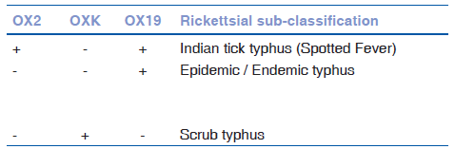
Table: Weil Felix interpretation
Scrub typhus (ST) is the most common rickettsial infection globally, but ocular involvement is infrequently reported. Early Indian studies documented conjunctival hemorrhages and lid edema without uveitis, and other studies found no ocular disease. Historical data from 1945–46 described uveitis in 1.3% of 451 ST patients, with additional findings including retinal vein engorgement, edema, hemorrhages, exudates, vitreous opacities, and histopathology showing diffuse subacute choroiditis.
Many earlier reports relied on Weil–Felix test, which is not a gold standard. Confirmatory tests (IgM/IgG ELISA or immunofluorescence) often tested negative.
Indian tick typhus (R. conorii) appears more strongly associated with uveitis, reported in series from India and Tunisia. Typical presentation is multifocal superficial retinitis 1–3 weeks after febrile illness, often with resolving rash. Clinical features include mild inflammation, subconjunctival hemorrhages, cotton wool spot-like lesions, disc or macular edema, and angiographic vasculitis. OCT shows inner retinal involvement.
The exact pathogenesis—direct infection vs immune-mediated—is uncertain. Retinitis has sometimes resolved with steroids alone, spontaneously, or worsened with steroids without antibiotics. Dramatic improvement is seen with systemic doxycycline. Evidence of rickettsiae within ocular tissue remains limited.
Current Management
- First-line: Doxycycline 100 mg twice daily for 2–3 weeks
- Steroids: Added based on intraocular inflammation or optic neuritis/vasculitis; may be avoided otherwise
- Alternatives: Ciprofloxacin (not for RMSF) and azithromycin; intravitreal chloramphenicol reported in endophthalmitis
Conclusion
Rickettsial infections should be considered in patients with retinitis and recent febrile rash illness. Though presentation can be severe with macular edema, visual prognosis is typically good, with rare recurrence.
Typhoid Retinitis
Typhoid fever can affect almost every ocular structure and may present during the acute infection or in the post-febrile immune phase. Acute ocular findings include conjunctivitis, keratitis, uveitis, choroiditis, vitritis, neuroretinitis, optic neuritis, and cranial nerve palsies. Post-fever manifestations include focal or multifocal retinitis, vasculitis, venous occlusion, neuroretinitis, serous detachment, frosted branch angiitis, endophthalmitis, and panophthalmitis. OCT typically shows inner retinal hyper-reflectivity corresponding to retinitis.
Diagnosis:
Blood culture is the gold standard but has low sensitivity (45–70%). Widal and serological tests have limited accuracy. PCR targeting the fliC gene improves detection, especially in patients already on antibiotics. IgG in serum and IgA in saliva may be helpful biomarkers.
Pathogenesis:
May involve direct invasion by S. typhi or immune-mediated mechanisms (molecular mimicry, autoimmunity). Vasculitis can result from endothelial tropism.
Management & Outcomes:
Treatment includes systemic antibiotics (e.g., ciprofloxacin) and steroids (topical to systemic). Severe cases need intravitreal antibiotics or vitrectomy. Visual outcomes vary; poor prognosis occurs with complications like retinal detachment or optic atrophy. Most recover to VA between 6/60 and 6/12 with residual RPE changes.
Dengue Retinitis & Dengue-related Ocular Involvement
Dengue virus (Flavivirus; serotypes DENV-1 to DENV-4) causes the most common mosquito-borne viral illness in humans. Most infections are mild and self-limiting flu-like episodes, but severe dengue can lead to hemorrhagic fever or shock syndrome. Laboratory diagnosis includes NS1 antigen testing early on, followed by IgM/IgG serology and RT-PCR.
Ocular Involvement
- Occurs in <10% of symptomatic dengue patients and is often bilateral.
- Typically appears 5–7 days after fever onset during the nadir of thrombocytopenia, suggesting immune-mediated pathology.
- Mechanisms include immune-complex deposition, antibody production, endothelial dysfunction, occlusive vasculopathy, ischemia, and apoptosis of endothelial cells.
- Visual outcomes vary from 20/20 to counting fingers, worse when foveolitis is present.
Clinical Findings
Posterior segment manifestations:
- Retinitis, retinal hemorrhages, vitreous hemorrhage
- Retinal vascular occlusion, macular edema, foveolitis (yellow-orange foveal lesion)
- Optic disc edema/hyperemia
- Multifocal chorioretinitis with nummular scars
Sight-threatening complications: 5–8% of cases
Imaging & Investigations
- OCT: CME, neurosensory detachment, foveolitis with outer retinal thickening, RPE alterations
- Types of maculopathy on OCT:
  - Type 1 – diffuse perifoveal edema
  - Type 2 – intraretinal CME + photoreceptor disruption
  - Type 3 – foveolitis
- OCT-A: decreased vessel density, deep plexus flow voids
- FFA: vasculitis, venular occlusion, leakage
- ICG: hypocyanescent spots, vessel hypercyanescence
- mfERG: decreased foveal/parafoveal responses
- Optic neuropathy reported rarely
Management
- Mostly conservative — spontaneous recovery common.
- Steroids for significant visual impairment (VA ≤ 20/40 or progressive loss):
  - Oral prednisolone, or
  - IV methylprednisolone for severe cases; IVIG if refractory
- Additional therapies: periocular/intravitreal steroids, vitrectomy for VH, laser iridotomy for angle closure
Prognosis
- Recovery occurs over days to months
- Persistent scotomas in ~59.5% at 2-year follow-up due to photoreceptor/bipolar cell loss
- mfERG abnormalities may persist up to a year
Key Takeaway
Dengue retinitis is mostly immune-mediated, occurring after fever resolution. Awareness and patient counseling regarding delayed ocular symptoms is essential; steroids may be beneficial in visually disabling cases.
West Nile Retinitis
West Nile virus (WNV) is a mosquito-borne flavivirus transmitted by Culex mosquitoes, with wild birds as reservoirs. It is globally distributed, and since 1999 has spread across the Americas. Most infections are asymptomatic or present as a mild febrile illness; severe neurologic disease (<1%) occurs mainly in elderly and diabetic individuals.
Ocular Manifestations
The most common eye involvement is multifocal chorioretinitis, seen in ~80% of patients with acute WNV and neurologic illness. It is usually bilateral, but may be unilateral. Symptoms range from none to mild visual reduction or floaters, with frequent mild-to-moderate vitritis.
Lesion Characteristics
- Active lesions: circular, deep yellow spots; early hypofluorescence and late staining on FA.
- Inactive lesions: round atrophic “target-like” pattern (central hypo- and peripheral hyperfluorescence).
- Number: <20 to >50 lesions per eye; Size: 200–1500 µm.
- Distribution: posterior pole (⅔), mid-periphery/periphery (almost all).
- Linear streaks along retinal nerve fiber layer in >80% cases.
- ICG shows more lesions than clinical exam or FA.
Other imaging: SD-OCT, FAF, OCT-A are helpful.
Retinal Vascular Involvement
Retinal hemorrhages, vascular sheathing, vascular leakage, and rare occlusive vasculitis (mainly elderly diabetics) associated with poor visual prognosis.
Additional Ocular Findings
- Anterior uveitis, retinitis, macular edema
- RPE atrophy, unilateral acute maculopathy
- Optic neuritis, neuroretinitis, disc swelling, nerve palsies, nystagmus
- Congenital chorioretinal scarring from intrauterine infection
Diagnosis
Based on clinical findings and confirmed by serology or PCR.
Management
- No proven antiviral treatment
- Supportive systemic therapy only
- Ophthalmic interventions:
  - Topical steroids for anterior uveitis
  - Laser photocoagulation for neovascularization
  - Vitrectomy for vitreous hemorrhage/TRD
  - Anti-VEGF for CNVM/macular edema
Prevention
Primary strategy—mosquito control and avoidance measures.
No vaccine currently available.
Chikungunya Retinitis
- Causative agent: Chikungunya virus, a single-stranded RNA alphavirus transmitted by Aedes aegypti mosquitoes.
- Systemic illness: Sudden fever with chills, headache, arthralgia/arthritis, rash, myalgia, vomiting, and persistent joint pain that may last months to years. Neurological complications like meningoencephalitis have been reported.
- Ocular involvement: Can occur during systemic illness or weeks later; may be unilateral or bilateral. Mechanism unclear—likely direct viral invasion vs delayed immune response.
- Clinical features:
  - Symptoms: blurred vision, visual field defects, color vision issues, central scotoma.
  - Findings: retinitis, neuroretinitis, choroiditis, optic neuritis; vitritis, disc hyperemia, retinal edema, hemorrhages, vascular involvement.
  - FFA: early hypofluorescence, late hyperfluorescence, vascular leakage.
  - OCT / OCTA: hyper-reflective inner retinal lesions, serous detachment, vascular density loss.
- Course and outcome: Usually self-limiting with recovery in 10–12 weeks; RPE changes may persist. Poor prognosis associated with macular ischemia and optic disc pallor. Recurrences are rare but reported.
- Diagnosis: PCR, serology (IgM/IgG).
- Treatment: Conservative management with topical/systemic steroids; rarely intravitreal steroids. No vaccine—mosquito control is key.

Zika Retinitis
- Causative agent: Zika virus, a flavivirus transmitted by Aedes aegypti.
- Systemic illness: Mild disease with fever, rash, conjunctival hyperemia, itching; may be associated with Guillain-Barré syndrome.
- Major significance: Strong association with congenital infection—microcephaly and severe ocular and neurological abnormalities.
- Ocular manifestations:
  - Congenital Zika syndrome: macular atrophy, RPE mottling, retinal hemorrhages, strabismus, congenital cataract, microcephaly.
  - Acquired infection (adults): non-granulomatous anterior uveitis, unilateral acute maculopathy, retinitis, inner retinal vasculopathy, pigment epithelial changes, multifocal choroiditis, optic neuritis.
- Investigations:
  - PCR: Gold standard (first week from blood; up to 14 days from urine).
  - Serology unreliable due to cross-reactivity with dengue.
- Outcome: Usually self-limiting with good recovery; many cases resolve without treatment.
- Treatment: Symptomatic; topical steroids for anterior uveitis. Supportive rehabilitation in congenital cases.
- Prevention: Mosquito control is the primary strategy.
REFERENCES

1. Shinde P, Daigavane S, Sharma A. Post-Fever Retinitis. Cureus. 2022 Jun;14(6):e26429.
2. Arunasri K, Sai Prashanthi G, Tyagi M, Pappuru RR, Shivaji S. Intraocular Viral Communities Associated With Post-fever Retinitis. Front Med. 2021;8:724195.
3. Mahendradas P, Kawali A, Luthra S, Srinivasan S, Curi AL, Maheswari S, et al. Post-fever retinitis - Newer concepts. Indian J Ophthalmol. 2020 Sep;68(9):1775–86.
4. Biswal S, Gondchawar A, Ravishankar HN, Sagar P, Shanmugam PM, Shah A, et al. Predictors of visual outcome in post-fever retinitis: a retrospective analysis. Int Ophthalmol. 2021 Dec;41(12):4099–109.

Pre-treatment and post- treatment photos
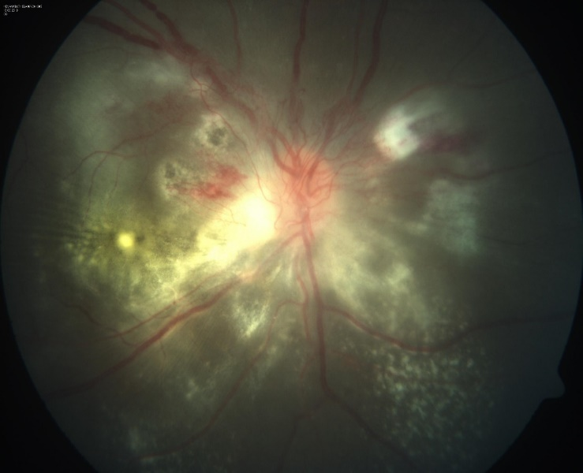
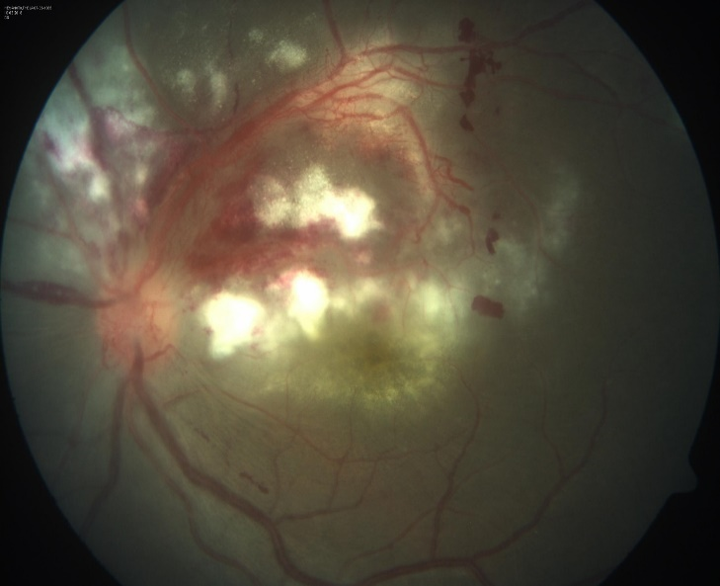
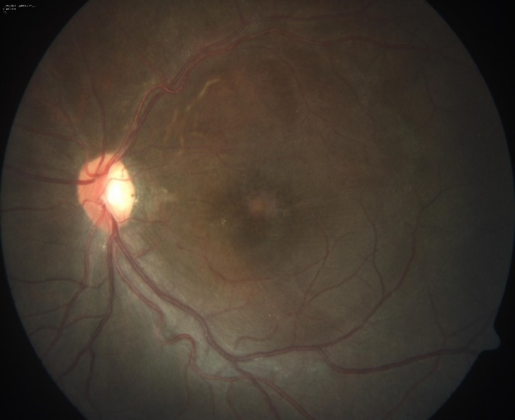
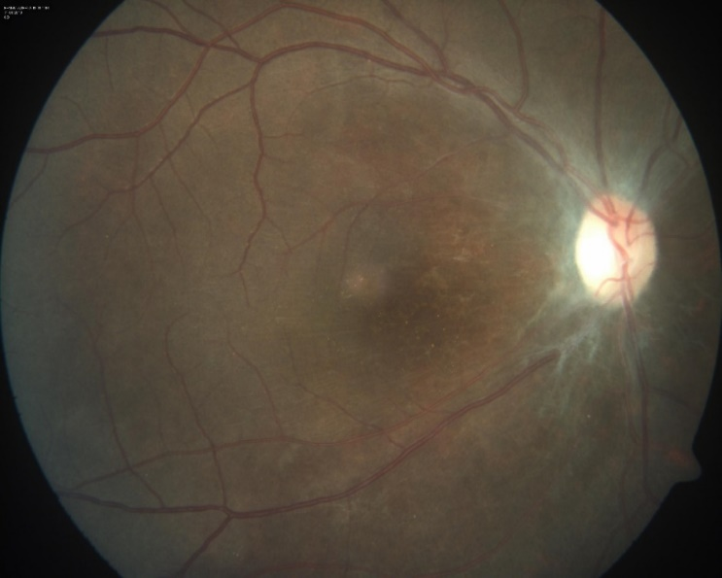

OCULAR SYPHILIS- Re-emergence of an old Foe
- Dr Mudit Tyagi,
Consultant and Head Of Services
Smt.Kanuri Santhamma Center for Vitreoretinal Diseases
Anant Bajaj Retina Institute
Consultant, Uveitis and Ocular Immunology Services
Kallam Anji Reddy Campus
L V Prasad Eye Institute
HYDERABAD - 500 034
Tel: +91-40-68102502
Syphilis is a systemic infectious disease caused by the spirochete bacterium Treponema pallidum (T. pallidum)
Transmission is most often during sexual contact - (acquired syphilis) (50 to 75 % of contacts acquire). However transplacental transmission from mother to fetus - after 10th week (congenital syphilis) is also known to occur
Incidence of Syphilis is again on a rise from the year 2000 onwards.
The 2015 statistics from The Center for disease control and prevention reported a 7.5 per 100,000 population of primary and secondary syphilis.
The total number of reported cases of syphilis (all stages) increased 13.3% during 2017–2018 (from 101,584 cases to 115,045 cases). ²

Why do we need to worry about Syphilis?
- Ocular syphilis can have varied manifestations and is seen in about 2.5 to 5% of patients with tertiary syphilis.
- Ocular manifestations occur in about 0.6-2% of all patients with syphilis at any stage of disease
- In a larger series by Vadboncoeur et al, posterior uveitis(29%) was the most common presentation of ocular syphilis followed by anterior uveitis and panuveitis

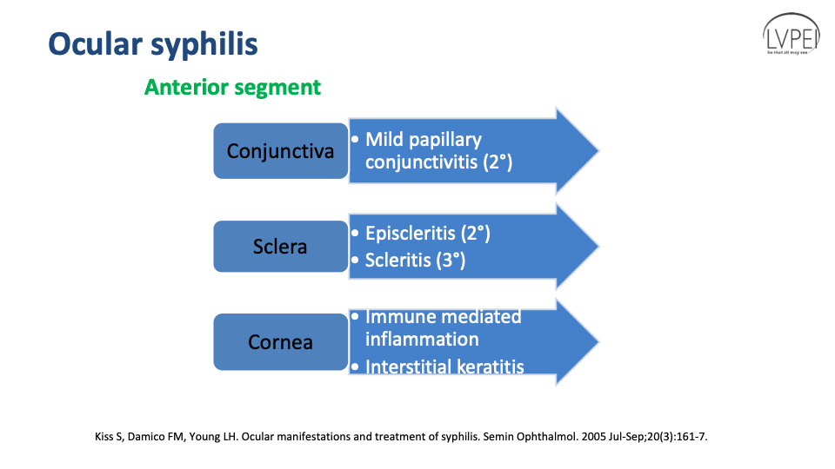

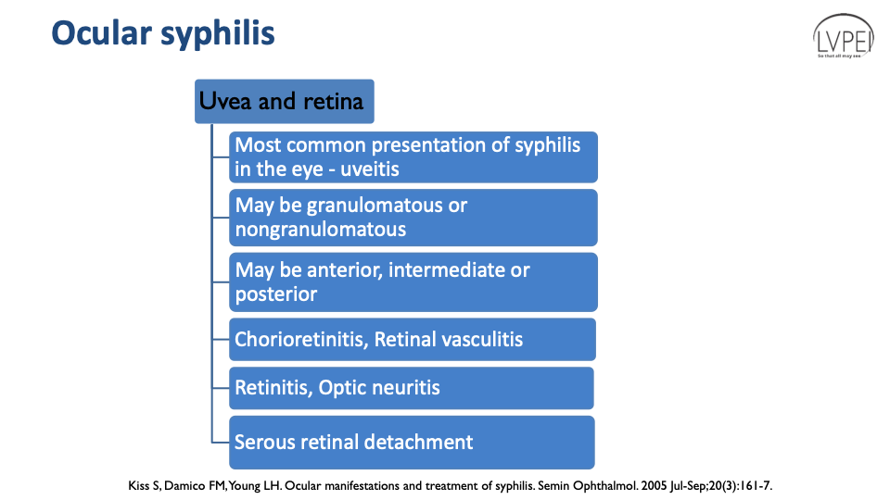

The most common phenotypes of Ocular Syphilis are:-
1. Acute Syphilitic Posterior Placoid Retinitis: Placoid retinitis lesions with more intense infiltration at the edge of the lesion. SD-OCT imaging in ASPPC demonstrates reversible, focal thickening, and nodularity of the RPE with disruption of the overlying photoreceptor inner segment-outer segment junction.
2. Ground Glass retinitis with central clearing and interspersed round, discrete small miliary lesions which show a full thickness retinitis on OCT

- 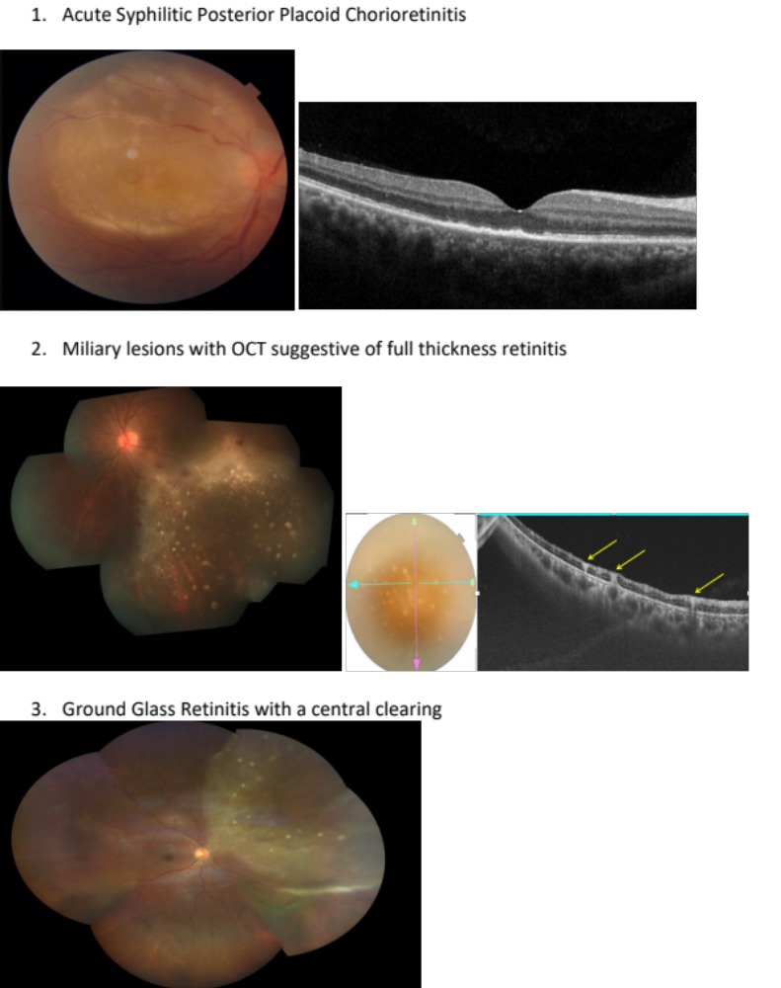

.
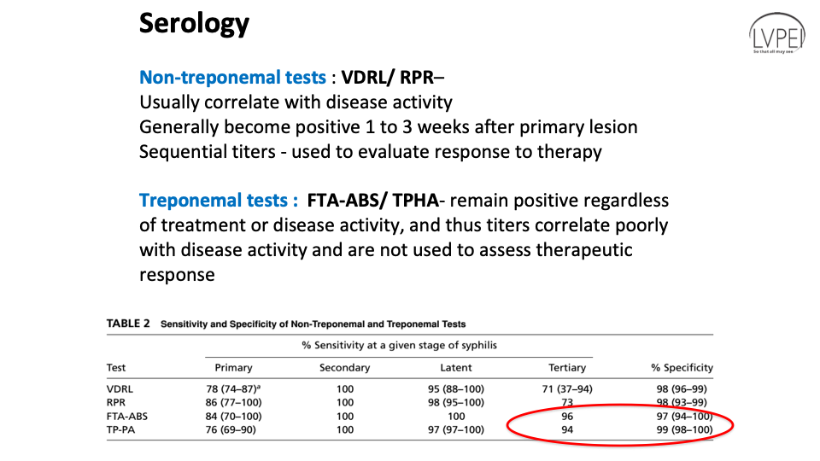

Treponemal tests like TPHA have a higher sensitivity and specificity for Ocular Syphilis and should be preferred over non treponemal tests like VDRL and RPR to make a diagnosis of Ocular Syphilis

CDC guidelines also recommend a reverse testing algorithm This includes using a treponemal test such as EIA or CLIA as a screening test followed by a non-treponemal test. This carries the advantage of detecting early cases because treponemal tests are more sensitive to early disease[67, 71].
For discordant samples, where there is a positive treponemal test and a negative non-treponemal test, a second treponemal test usually TPPA, is recommended. Still, If TPPA is negative and the patient is at high risk for having syphilis, RPR should be repeated in several weeks[

Treatment

Ocular Syphilis should be treated on lines similar to Neurosyphilis

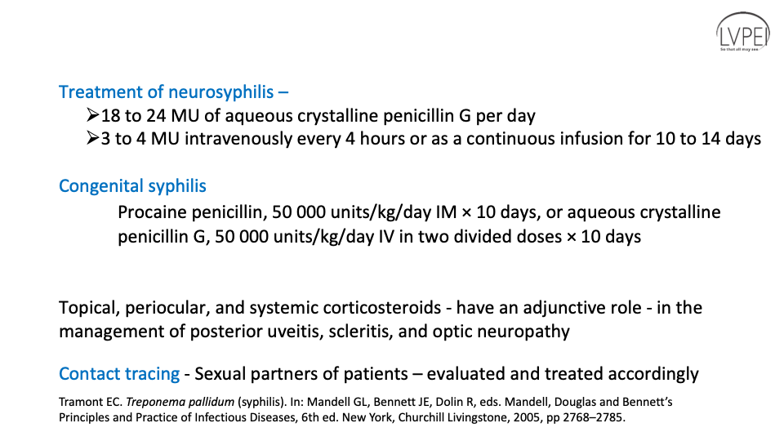

In cases of allergy to Penicillin or non availability:-
- Oral Doxycycline 200 mg BD for 28 days can also be used for treatment of Ocular Syphilis
- Ceftriaxone was suggested as a penicillin substitute in late 1980s. It has been reported that ceftriaxone 1-2 g intramuscularly (IM) daily for 14 days was effective in treating patients with ocular syphilis.
References:
1 Chauhan K, Fonollosa A, Giralt L, Artaraz J, Randerson EL, Goldstein DA, Furtado JM, Smith JR, Sudharshan S, Ahmed AS, Nair N, Joseph J, Pavesio C, Westcott M, Trepatchayakorn S, Sallam AB, Elhusseiny AM, Tyagi M. Demystifying Ocular Syphilis - A Major Review. Ocul Immunol Inflamm. 2023 Sep;31(7):1425-1439. doi: 10.1080/09273948.2023.2217246.
2.Furtado JM, Simões M, Vasconcelos-Santos D, Oliver GF, Tyagi M, Nascimento H, Gordon DL, Smith JR. Ocular syphilis. Surv Ophthalmol. 2022 Mar-Apr;67(2):440-462. doi: 10.1016/j.survophthal.2021.06.003. Epub 2021 Jun 18. PMID: 34147542.
3. Sudharshan S, Menia NK, Selvamuthu P, Tyagi M, Kumarasamy N, Biswas J. Ocular syphilis in patients with human immunodeficiency virus/acquired immunodeficiency syndrome in the era of highly active antiretroviral therapy. Indian J Ophthalmol. 2020 Sep;68(9):1887-1893. doi: 10.4103/ijo.IJO_1070_20.

TB OR NOT TB – A PERENNIAL QUESTION
Dr. Sudha K Ganesh
Professor of Ophthalmology, Cataract Services and Uveitis
Director Department of Intraocular Inflammation.
Medical Research Foundation, Sankara Nethralaya
No 18, College Road
Chennai 600006. India
Mobile: 9840791158

- Ocular tuberculosis (OTB) is an extrapulmonary form of tuberculosis with highly variable clinical expression making it a diagnostic challenge.
- On a global level, its prevalence accounts to only 4% of all uveitis cases but expands to 22.9 – 48% in endemic regions including India.¹
- Although there are a wide range of investigations available for confirmative diagnosis of tuberculosis (TB) in the present era, ocular diagnosis still remains tricky at situations owing to its paucibacillary nature of presentation in the ocular tissue.
- Hence, in certain scenarios it remains a presumed diagnosis.
- This talk outlines the controversies in the diagnosis and clinical clues to differentiate it from other uveitides.

WHY CONTROVERSY EXISTS?

CLINICAL PHENOTYPES OF TB:
- The varied clinical presentations of OTB includes granulomatous anterior uveitis with mutton-fat keratic precipitates, intermediate uveitis, posterior uveitis (choroidal tuberculoma, multifocal choroiditis, serpiginous like choroiditis, subretinal abscess), occlusive retinal vasculitis, and scleritis. Whereas rare manifestations include conjunctival or optic nerve involvement (Neuroretinitis, optic neuropathy).²
- Of these, broad-based posterior synechiae, retinal vasculitis, serpiginous like choroiditis are predictive features suggestive of tuberculosis in an endemic region.³

HOW TO DIAGNOSE:
- Confirmation of the disease through direct isolation of the bacilli is not always possible owing to low bacterial load, small volume of sample and variability in the yield of molecular diagnostics.
- Polymerase chain reaction (PCR) is being utilised more frequently in this decade for diagnosis from intraocular samples.⁴
- In some situations, the diagnosis remains presumed. This is based on presence of compatible clinical features with evidence suggestive of exposure to TB like interferon gamma release assay (IGRA) and/or tuberculin skin test (TST) positivity. This holds good in high-risk / endemic population.⁵

THE “NOT-TB” ENTITIES TO LOOK FOR:
- In case of granulomatous uveitis presentation, the differentials to be considered are Sarcoidosis, Syphilis, Viral uveitis, Leprosy, Vogt-Koyanagi Harada syndrome and Sympathetic ophthalmia.
- In choroidal granuloma presentation, the differentials include Sarcoidosis, Syphilis, Fungal infections, Toxoplasmosis and Toxocariasis.
- The one disease with similar ocular and extraocular features is sarcoidosis – considered the closest differential. Some authors have suggested both to be the diseases of same spectrum.⁶
- The serpiginous like choroiditis needs to be differentiated from acute posterior multifocal placoid pigment epitheliopathy (APMPPE) and classic serpiginous choroiditis.
- Multimodal imaging aids in the diagnosis of tuberculosis. Studies have shown its utilization in addition to the clinical features in differentiating tubercular and sarcoid granulomas.⁷

UPDATES ON DIAGNOSTIC TOOLS IN TB:
- Collaborative Ocular Tuberculosis Study (COTS) experts devised a COTS calculator which is an effective, evidence-based clinical tool to guide the initiation of anti-tubercular therapy (ATT).⁸
- Standardization of Uveitis (SUN) working group proposed a classification criteria to improve the consistency in diagnosis and reduce the misclassification rates.⁹
A clinical judgement with integration of presenting phenotype, contact risk, immunological testing and imaging help in enhancing the diagnostic accuracy

REFERENCES
- Ludi Z, Sule AA, Samy RP, Putera I, Schrijver B, Hutchinson PE, Gunaratne J, Verma I, Singhal A, Nora RD, van Hagen PM, Dik WA, Gupta V, Agrawal R. Diagnosis and biomarkers for ocular tuberculosis: From the present into the future. Theranostics. 2023 Apr 1;13(7):2088-2113.
- Gupta V, Gupta A, Rao NA. Intraocular tuberculosis--an update. Surv Ophthalmol. 2007;52(6):561-587.
- Gupta A, Bansal R, Gupta V, Sharma A, Bambery P. Ocular signs predictive of tubercular uveitis. Am J Ophthalmol. 2010;149(4):562-570.
- Biswas, Jyotirmay; Kazi, Mohmmad Salman1; Agarwal, Vishvesh Ashokkumar1; Alam, Md. Shahid2; Therese, K Lily3. Polymerase chain reaction for Mycobacterium tuberculosis DNA detection from ocular fluids in patients with various types of choroiditis in a referral eye center in India. Indian Journal of Ophthalmology 64(12):p 904-907, December 2016.
- Campbell, J. R., Pease, C., Daley, P., Pai, M., & Menzies, D. (2022). Chapter 4: Diagnosis of tuberculosis infection. Canadian Journal of Respiratory, Critical Care, and Sleep Medicine, 6(sup1), 49–65.
- Agrawal R, Kee AR, Ang L, et al. Tuberculosis or sarcoidosis: Opposite ends of the same disease spectrum?. Tuberculosis (Edinb). 2016;98:21-26.
- Agarwal A, Aggarwal K, Pichi F, et al. Clinical and Multimodal Imaging Clues in Differentiating Between Tuberculomas and Sarcoid Choroidal Granulomas. Am J Ophthalmol. 2021;226:42-55.
- Agrawal, R., Ludi, Z., Betzler, B.K. et al. The Collaborative Ocular Tuberculosis Study (COTS) calculator—a consensus-based decision tool for initiating antitubercular therapy in ocular tuberculosis. Eye 37, 1416–1423 (2023).
- Standardization of Uveitis Nomenclature (SUN) Working Group. Classification Criteria for Tubercular Uveitis. Am J Ophthalmol. 2021;228:142-151.

